Chapter1

**INTRODUCTION**

Project's main objective is to maintain students achievements of a particular college in all the fields and to make retrive of data more easier. It is pride of the college that their students have won medals or prizes in any competitons. So, they are willing to storethe the students achivements as the years goes on the number of records increases and it is not easy to handle them an searching of records with particular requirements is much more complex. The software reduces all these problems and helps to manage student achievements.

# 

# **2.SYSTEM ANALYSIS**

## **Software Requirement Specifications**

Software Requirement Specification is the starting point of software developing activity. As system grew more complex it became evident that the goal of the entire system cannot be easily comprehended. Hence the needs for the requirements phase are use. The software project is initiated by the clientneeds. The SRS is the means of translating the ideas of the minds of clients (the input) into a formal document. The purpose of the software requirement specification is to reduce the communication gap between the clients and developers. Software Requirement Specification is the medium through which the client and user needs are accurately specified. It forms the basis of software development. A good SRS should satisfy all the parties of involved in the system. The SRS phase consists of two basic activities.

## **2.1.1Purpose**

The objective of Student Achievement Automatic Management System is to allow the administrator of any organization to edit and find out the achievement details of a student and allows the student to keep up to date his profile . It’ll also facilitate keeping all the records of students, such as their id, name, mailing address, phone number, DOB etc. So all the information about achievements of an student will be available in a few seconds. Based on the is reports can be easily generated about the achievements made by students of the college Overall, it’ll make Student Achievement Automatic Management System is an easier job for the administrator and the student of any organization. The main purpose of this SRS documentis to illustrate the requirements of the project Student Achievement Automatic Management System and is intended to help any organization to maintain and manage its student’sdata.

## **2.1.2 Scope**

## It consists of different modules. They are as follows

**Login module**: Login module will help in authentication of user accounts .Users who have valid login id and password can only login into their respective accounts.

**Search module**: Suppose there are hundreds of achievements of students and from this we have to search a particular student and we know the name of the student .In manual system it is a tedious task though we know the name of the student, but using this module we can easily search the student by specifying the name of the student in the search criteria. Thus this module will help the administrator in searching a student’s achievements with various criteria easily.

**Registration Module and Account Management**: This module will help the

student get registered from anywhere if internet is present .This module will

really simplify the task of on paper registration. Also after successful registration the user can update information and change their password as and when required.

**User Management**: This module will help the administrator in enabling/disabling a user account and updating user information as required. Purpose of project is to maintain details of the students such as storing information about:

Student id, Student password, Student name, Student DOB, Student mailing address, Gender Registration date, Student status, Contact no, Qualification, City, marks, attendance, Promotion of the students list.

## **2.1.3Objective**

The objective of the software is to built an automatic system for

the entry, search and update of student’s achievements information

and to maintain a large number of records very easily and fastly.

**2.1.3.1.Existing** **System**: There are various existing similar type of systems ,which uses file systems, records and manual data files.

**Limitations:**

The major limitation is that retrieving and inserting in datafiles and records is more complex and takes a lot of time for any operation.

## **2.1.5Proposed System**

The proposed application software to be developed is for SIS that performs few of the major actions. The major modules in the system are:

1. Administrator

2. Faculty

3. Student

**Administrator:** In this system, the administrator is the Head of the Department and faculty who can add, modify and delete the students achievements . Administrator assigns access to faculty. He has every right to modify already entered achievements.

In this we require.

Admin login (name, password)

**Student**: Student is added by the administrator. In this we require.

Student details (name, rollno, branch, yearofjoining, address, state, pin, phone, mobile, email, sem, gender).

Student has the privilege to view the student’s Achievements.

**Faculty**: Faculty is added by administrator. Faculty can enter the system through their respective login information. The role of the faculty is to enter achievements of students.

faculty(faculty_id, name, password)

**Achievements** :The achivements contain following attributes

Achievement(date , studentid , event ,organization, details)

**2.1.6. Problem Statement**

The problem statement is to manage a large number of achievements. The n.o of achievements are increasing year by year in a large number. So, the main problem is to maintain and handle retrieval requests with large speed.

## **2.2.Functional Requirements**

## This application should be able to accept the achievements data information

Any user can search for any achievements based on requirements.

There is a constraint that faculty should be registered and then logged in, in order to insert, update an delete.

## **2.3Non-functional Requirements**

**2.3.1 User Interfaces**

For the user to interact with the system easily, we need to provide interfaces in such a way that a user who has no computer knowledge can also easily access.

**2.3.2 Hardware Interfaces**

These are the Hardware interfaces used

Processor: Intel Pentium 4 or equivalent

RAM: Minimum of 256 MB or higher

HDD: 10 GB or higher

Monitor: 15’’ or 17’’ color monitor

Mouse: Scroll or optical mouse

Keyboard: Standard 110 keys keyboard

Printer:Any

**2.3.3 Software Interfaces**

Connections between the front end and back end.

In this Student Achievement Automatic Management System we used Front end: Apache Tomcat with port number:8098. Back end Oracle with port number:8080.

**2.3.4 Communications Interface**s

Client (customer) on Internet will be using HTTP/HTTPS protocol.

Client (system user) on Internet will be using HTTP/HTTPS protocol.

**2.4. Other Nonfunctional Requirements**

**2.4.1 Performance Requirements:**

The proposed system that we are going to develop will be used as the Chief performance system for providing help to the organization in managing the whole database of the student achievements. Therefore, it is expected that the database would perform functionally all the requirements that are specified.

**2.4.2 Safety Requirements:** The database may get crashed at any certain time due to virus or operating system failure. Therefore, it is required to take the database backup.

**2.4.3 Security Requirements:** We are going to develop a secured database. There are different categories of users namely Administartor ,Student who will be viewing either all or some specific information form the database. Depending upon the category of user the access rights are decided. It means if the user is an administrator then he can be able to modify the data, append etc. All other users only have the rights to retrieve the information about database.

**2.4.4 Software Quality Attributes:**Quality characteristics for the product that will be important to either the customers or the developers. Some to consider are: adaptability, availability, correctness, flexibility, interoperability, maintainability, portability, reliability, reusability, robustness, testability, and usability. Write these to be specific, quantitative, and verifiable when possible. At the least, clarify the relative preferences for various attributes, such as ease of use over ease of learning

# **3.SYSTEM DESIGN**

The designer’s goal is how the outputs to be produced and in what format samples of the output are also presented. The processing phases are handled through the program construction and testing. Finally details related to justification of the system and an estimate of the impact of the candidate system on the user and the organization are documented and evaluated by management as a step towards implementation.

The importance of software design can be stated in a single word “Quality”. Design provides us with representations of software that can be assessed for quality. Design is the only way that can be able to accurately translate a customer’s requirements into a finished software product or system without design risk, building an unstable system, that might fail it if small changes are made or may be difficult to test, or one who’s quality can’t be tested. So it is essential phase in the development of a software product.

Object-oriented design can yield the following benefits:

Maintainability through simplified mapping to the problem domain, which provides for less analysis effort, less complexity in system design, easier verification by the user.

Reusability of the design artifacts, which saves time and cost.

## **3.1. System Architecture**

System Architecture describes “the overall structure of the system and the ways in which the structure provides conceptual integrity”.

Architecture is the hierarchical structure of a program components (modules), the manner in which these components interact and the structure of data that are used by that components.

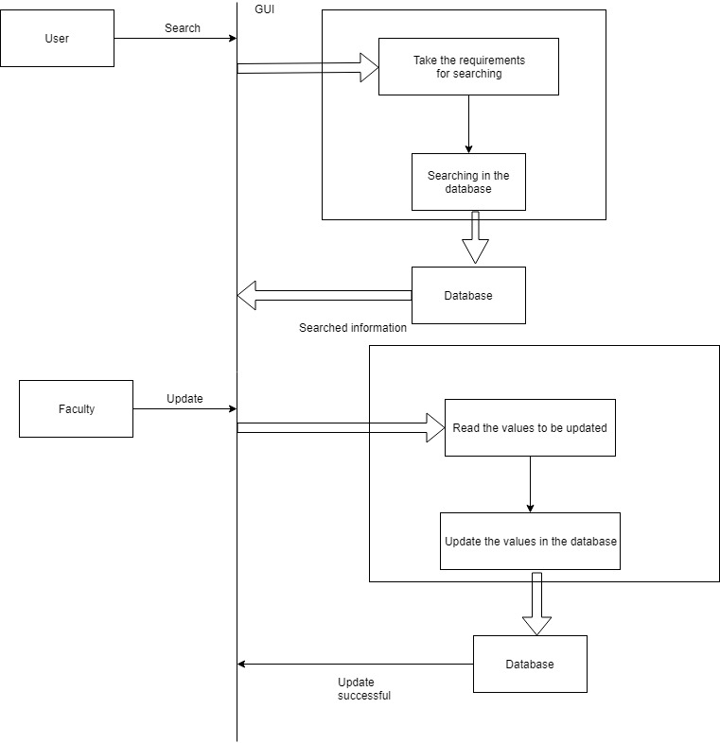

## **3.2.UML Design**

UML stands for Unified Modeling Language. Taking SRS document of analysis as input to the design phase drawn UML diagrams. The UML is only language so is just one part of the software development method. The UML is process independent, although optimally it should be used in a process that should be driven, architecture-centric, iterative, and incremental. The UML is language for visualizing, specifying, constructing, documenting the articles in a software-intensive system.

A modeling language is a language whose vocabulary and rules focus on the conceptual and physical representations of the system. A modeling language such as the UML is thus a standard language for software blueprints.

The UML is a graphical language, which consists of all interesting systems. There are

also different structures that can transcend what can be represented in a language. There are different diagrams in UML

## **3.2.1Data Flow Diagram**

The DFD is also called as bubble chart. It is a simple graphical formalism that can be used to represent a system in terms of the input data to the system, various processing carried out on these data, and the output data is generated by the system.

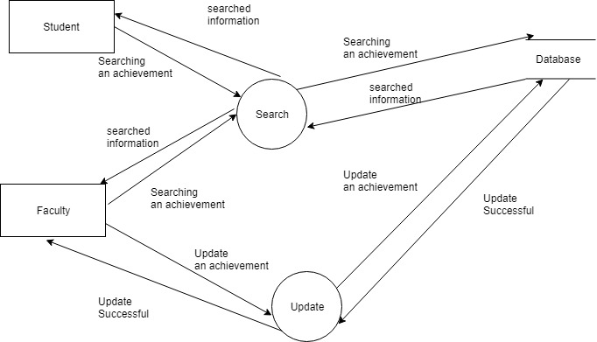

Fig 3.2 Data-flow Diagram for online house rental system

## **3.2.1.Use Case Diagram**

Use Case during diagram requirement elicitation and analysis to represent the functionality of the system. Use Case describes a function provided by the system that yields a visible result for an actor.

The identification of actors and use cases result in the definition of the boundary of the system i.e., differentiating the tasks accomplished by the system and the tasks accomplished by its environment. The actors are outside the boundary of the system, whereas the Use cases are inside the boundary of the system. Use Cases describe the behavior of the system as seen from the actor’s point of view. It describes the function provided by the system as a set of events that yield a visible result for the actor.

Fig 3.2.1.Use case Diagram

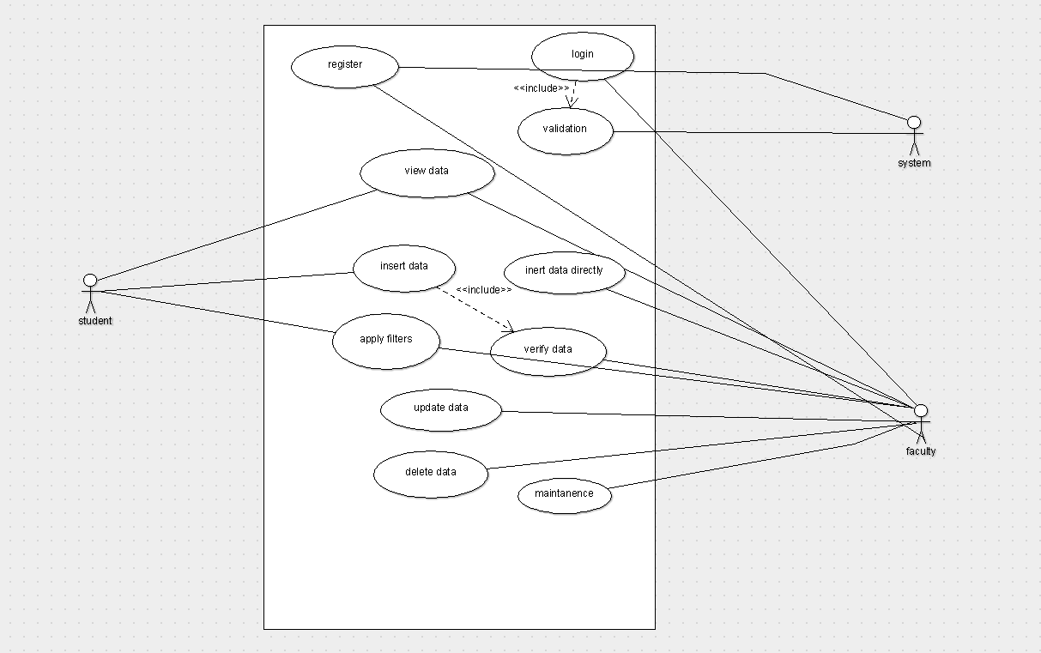

## **Class diagram**

Class diagrams model class structure and contents using design elements such as classes, packages and objects. Class diagram describe three different perspectives when designing a system- conceptual, specification and implementation.

Fig 3.2.3.Class Diagram

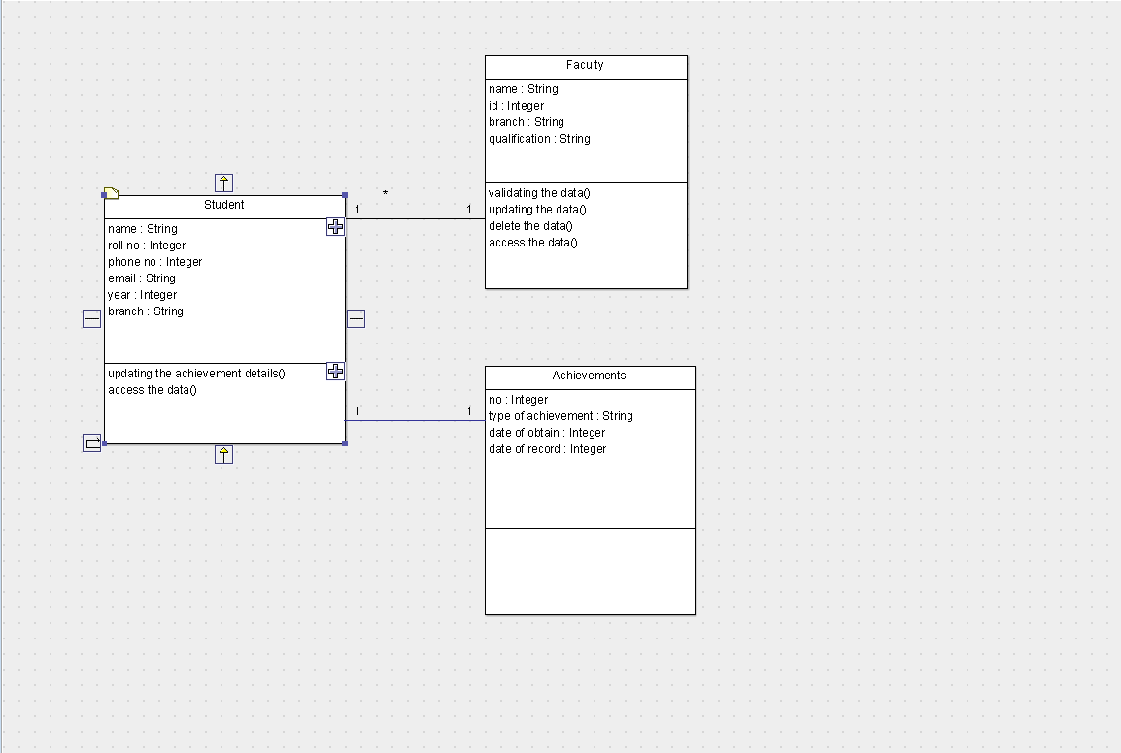

# **3.2.4Interaction diagrams**

## **Sequence diagrams**

## Sequence diagram displays the time sequence of the objects participating in the interaction. This consists of the vertical dimension (time) and horizontal dimension (different objects).

Object: Object can be viewed as an entity at a particular point in time with a specific value and as a holder of identity that has different values over time.

Actor: An Actor represents a coherent set of roles that users of a system play when

interacting with the use cases of the system.

Message: A message is sending of a signal from one sender object to other receiver object(s).

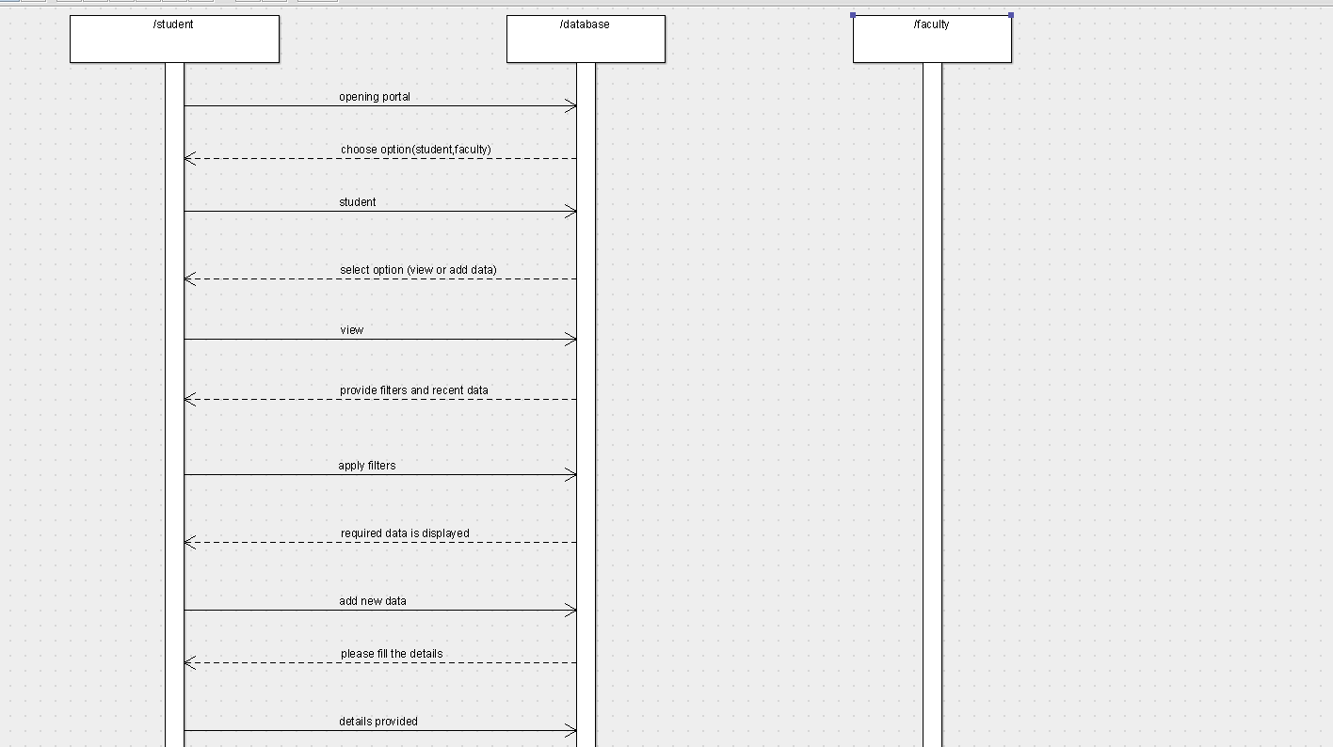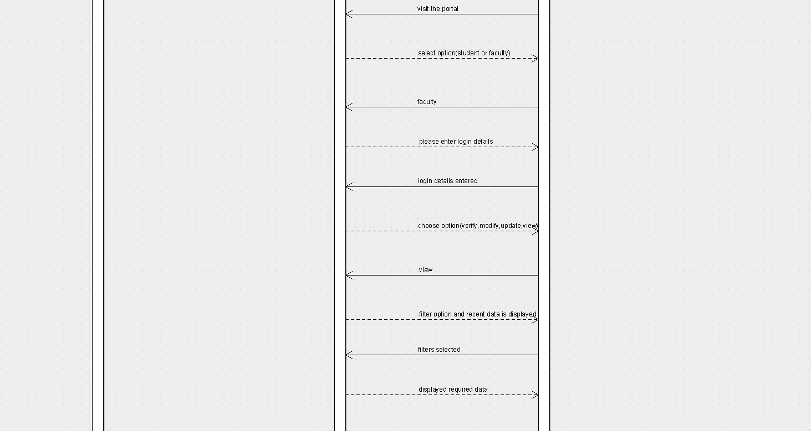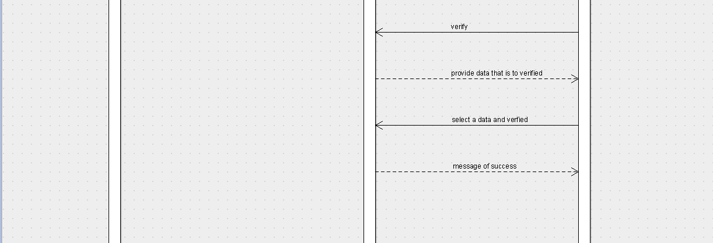

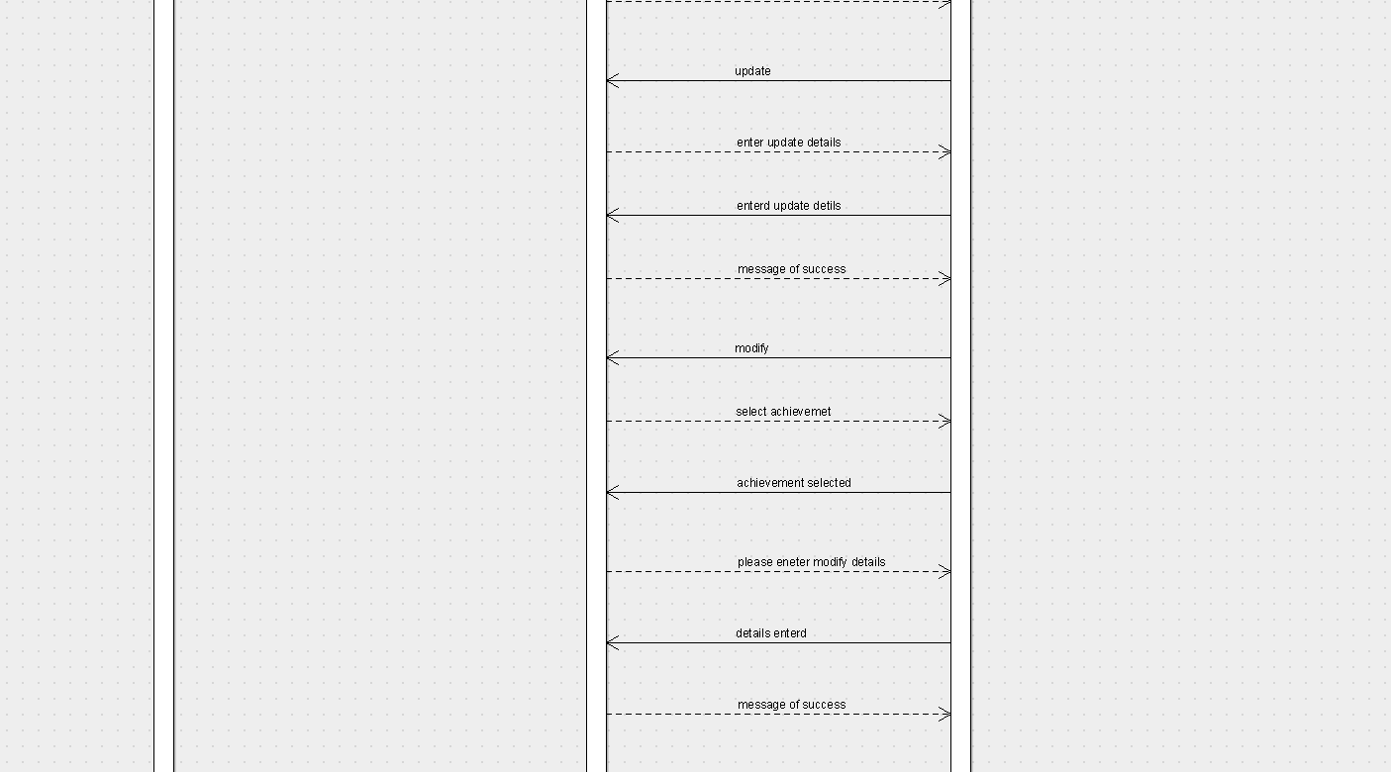

Fig 3.2.4.1. Sequence Diagram

**Collaboration** **diagrams**

Collaboration diagram displays an interaction organized around the objects and their links to one another. Numbers are used to show the sequence of messages

A collaboration diagram resembles a flow chart , that portrays the roles, functionality and behavior of individual objects as well as the overall operation of the system in real time. Objects are shown as rectangles with naming labels inside. These labels are preceded by colons and may be underlined. The relationships between the objects are shown as lines connecting the rectangles. The messages between objects are shown as arrows connecting the relevant rectangles along with labels that define the message sequencing.

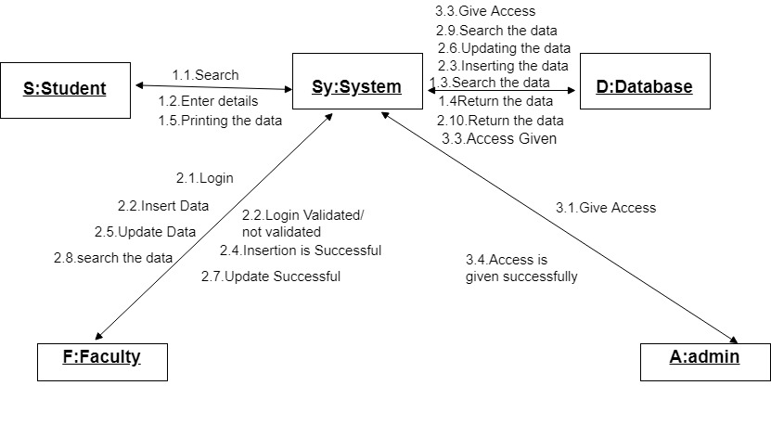

Fig 3.2.4.2 Collaboration Diagram

# **3.2.5.Activity diagram**

An activity diagram shows the flow from activity to activity. An activity is a going non-atomic execution with in a state machine. An activity results in some action, results in a change of state or return of a value.

Activity Diagram commonly contains

Activity states and action states.

Transitions.

Objects, it may contain nodes and constraints.

Activity states and action states: An executable atomic computation is called action state, which cannot be decomposed. Activity state is non atomic, decomposable and takes some duration to execute.

Transition: It is the path from one state to the next state, represented as simple directed line.

Branching: When an alternate path exists, branching arises which is represented by open diamond. It has an incoming transition, two or more outgoing transitions.

Forking and joining: The synchronization bar when split one flow into two or more flows is called fork. When two or more flows are combined at synchronization bar, the bar is called join.

Swim Lanes: Group work flow is called swim lanes. All groups are portioned by vertical solid lines. Each swim lane specifies locus of activities and has a unique name. Each swim lane is implemented by one or more classes. Transition may occur between objects across swim lanes.

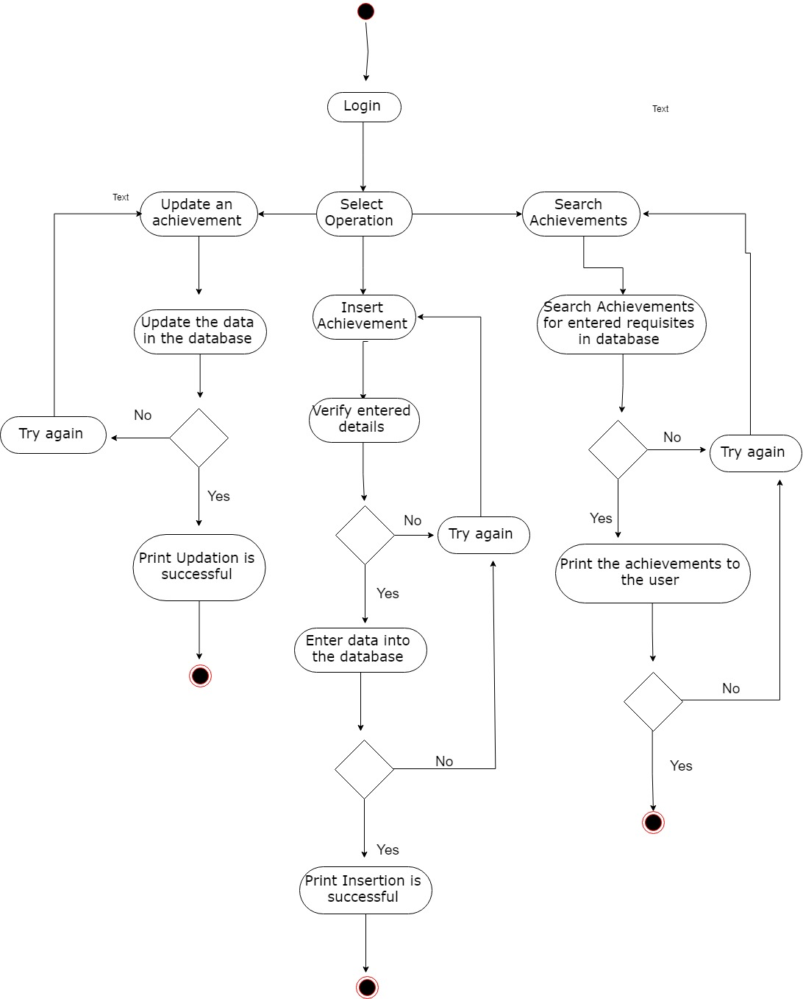

Fig 3.2.5. Activity Diagram

**3.2.6.State Diagrams:**

A state machine is any device that stores the status of an object at a given time and can change status or cause other actions based on the input it receives. States refer to the different combinations of information that an object can hold, not how the object behaves. In order to understand the different states of an object, you might want to visualize all of the possible states and show how an object gets to each state, and you can do so with a UML state diagram.

Each state diagram typically begins with a dark circle that indicates the initial state and ends with a bordered circle that denotes the final state. However, despite having clear start and end points, state diagrams are not necessarily the best tool for capturing an overall progression of events. Rather, they illustrate specific kinds of behavior—in particular, shifts from one state to another.

State diagrams mainly depict states and transitions. States are represented with rectangles with rounded corners that are labeled with the name of the state. Transitions are marked with arrows that flow from one state to another, showing how the states change. Below, you can see both these elements at work in a basic diagram for student life. Our [UML diagram tool](https://www.lucidchart.com/pages/examples/uml_diagram_tool) can help you design any custom state machine diagram.

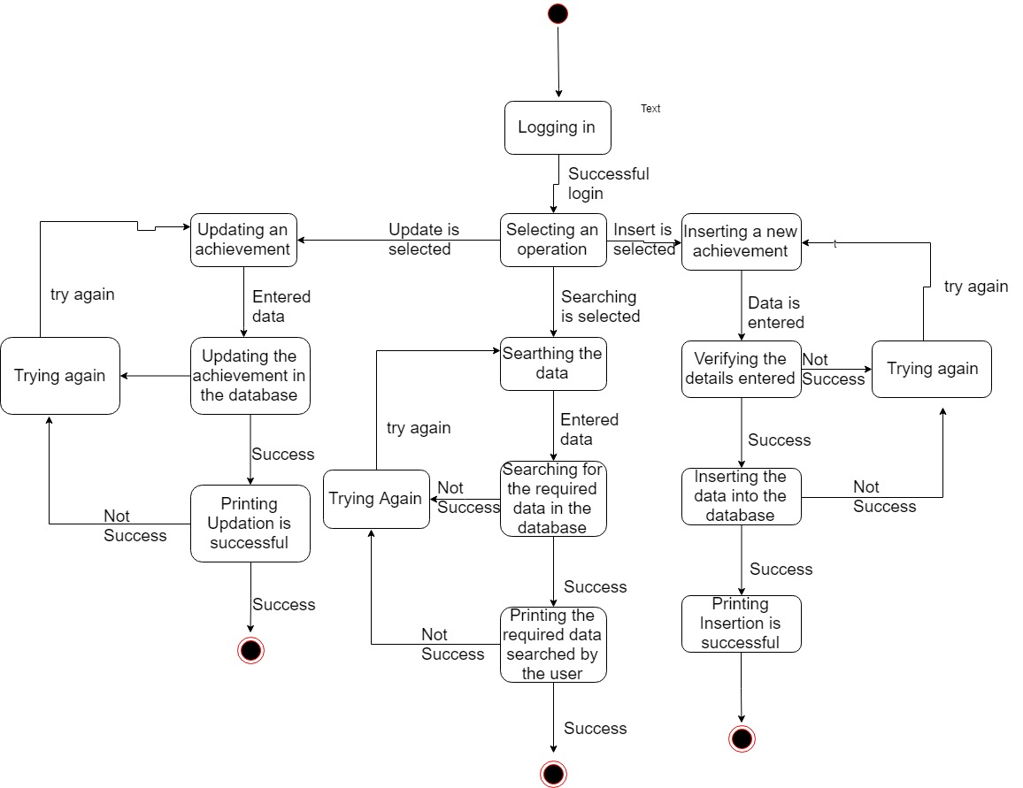

Fig 3.2.6. State Diagram

# **Chapter4 IMPLEMENTATION**

Implementation is the stage where the theoretical design is turned into a working system. The most crucial stage in achieving a new successful system and in giving confidence on the system for the users that will work efficiently and effectively. The system will be implemented only after thorough testing and if it is found to work according to the specification.

## **Overview of Software Used**

This application is developed and executed with xamp and user interface is implemented using html,css and php code is used for database insertions.

## **FRONTEND** **HTML:**

Hypertext Markup Language is the standard markup language for creating web pages and web applications. With Cascading Style Sheets and JavaScript, it forms a triad of

cornerstone technologies for the World Wide Web.It is a very easy and simple language. It can be easily understood and modified.It is very easy to make effective presentation with HTML because it has a lot of formatting tags.It is a markup language so it provides a flexible way to design web pages along with the text.It facilitates programmers to add link on the web pages (by html anchor tag) , so it enhances the interest of browsing of the user.It is platform-independent because it can be displayed on any platform like Windows, Linux and Macintosh etc. It facilitates the programmer to add Graphics, Videos, and Sound to the web pages which makes it more attractive and interactive.

## **CSS:**

Cascading Style Sheets, fondly referred to as CSS, is a simple design language intended to simplify the process of making web pages presentable.

CSS handles the look and feel part of a web page. Using CSS, you can control the color of the text, the style of fonts, the spacing between paragraphs, how columns are sized and laid out, what background images or colors are used, layout designs,variations in display for different devices and screen sizes as well as a variety of other effects.

## **BACKEND PHP:**

PHP (recursive acronym for PHP: Hypertext Preprocessor) is a widely-used open source general-purpose scripting language that is especially suited for web development and can be embedded into HTML.

What distinguishes PHP from something like client-side JavaScript is that the code is executed on the server, generating HTML which is then sent to the client. The client would receive the results of running that script, but would not know what the underlying code was. You can even configure your web server to process all your HTML files with PHP, and then there's really no way that users can tell what you have up your sleeve.

## **XAMPP SERVER:**

A platform is the hardware or software environment in which a program runs. Platforms like Windows 2000, Linux, Solaris, and MacOS. XAMPP is meant only for development purposes. It has certain configuration settings that make it easy to develop locally but that are insecure if you want to have your installation accessible to others.

Xampp Server is a utility designed to allows you to create Web applications and manage your server and databases. XampServer is a Windows web development environment. It allows you to create web applications with Apache2, PHP and a MySQL database. It also comes with PHPMyAdmin and SQLiteManager to easily manage your databases. Xampp Server installs automatically (installer), and its usage is very intuitive. You will be able to tune your server without even touching the setting files. WampServer is the only packaged solution that will allow you to reproduce your production server. Once WampServer is installed, you have the possibility to add as many Apache, MySQL, and PHP releases as you want. WampServer also has a tray icon to manage your server and its settings.

# **4.2.Sample code**:

<!DOCTYPE html>

<html>

<style>

input[type=text], select {

width: 100%;

padding: 13px 20px;

margin: 7px 0px;

display: inline-block;

border: 1px solid #ccc;

border-radius: 4px;

box-sizing: border-box;

}

input[type=password], select {

width: 100%;

padding: 13px 20px;

margin: 7px 0px;

display: inline-block;

border: 1px solid #ccc;

border-radius: 4px;

box-sizing: border-box;

}

input[type=submit] {

width: 50%;

background-color: #4CAF50;

color: white;

padding: 15px 20px;

margin: 0px 0px;

border: none;

border-radius: 4px;

cursor: pointr;

}

input[type=submit]:hover {

background-color: #45a049;

}

div {

margin-top: 50px;

margin-bottom: 50px;

margin-right: 400px;

margin-left: 400px;

background-color: #ECF0F1;

padding: 50px

}

h2{

color: black;

}

</style>

<body background="for.jpg">

<div>

<h1><center>Faculty Login</center></h1>

<form action="/action_page.php" method="POST">

<h2>User Name</h2>

<input type="text" id="uname" name="username" placeholder="Type here...."><br>

<h2>Password</h2>

<input type="password" id="pass" name="password" placeholder="Your password.."><br><br><br>

<input type="submit" value="Submit">

<h4><font color="red">*Note:</font> If not registered please contact admin</h4>

</form>

</div>

</body>

</html>

**PHP**

<?php

$conx=mysqli_connect('127.0.0.1','root','');

if(!$conx)

{

echo 'not connected';

}

if(!mysqli_select_db($conx,'achievement'))

{

echo 'database not selected';

}

$uname=$_POST['uname'];

$Name=$_POST['name'];

$Roll=$_POST['rollno'];

$Year=$_POST['year'];

$Branch=$_POST['branch'];

$pass=$_POST['pass'];

$sqlx="INSERT INTO student (username,name,password,rollno,year,branch,) VALUES('$uname','$Name','$pass','$Roll','$Year','$Branch')";

if(!mysqli_query($conx,$sqlx))

{

echo 'not inserted';

}

else

{

echo 'inserted';

}

header("refresh:15; url=ii.html");

?>

# **Chapter 5 TESTING**

The purpose of testing is to discover errors. Testing is the process of trying to discover every conceivable fault or weakness in a work product. It provides a way to check the functionality of components, sub assemblies, assemblies and/or a finished product. It is the process of exercising software with the intent of ensuring that the software system meets its requirements and user expectations and does not fail in an unacceptable manner.

Software testing is an important element of the software quality assurance and represents the ultimate review of specification, design and coding. The increasing feasibility of software as a system and the cost associated with the software failures are motivated forces for well planned through testing.

## Testing Objectives

These are several rules that can save as testing objectives they are:

Testing is a process of executing program with the intent of finding an error.

A good test case is one that has a high probability of finding an undiscovered error.

## **5.1.Types of testing**

In order to make sure that the system does not have errors, the different levels of testing strategies that are applied at differing phases of software development are:

## **5.1.1Unit Testing**

## Unit Testing is done on individual modules as they are completed and become executable. It is confined only to the designer's requirements. Unit testing is different from and should be preceded by other techniques, including:

* + - * Inform debugging,Code inspection

**Black Box Testing**

In this strategy some test cases are generated as input conditions that fully execute all functional requirements for the program. This testing has been used to find error in the following categories:

* Incorrect or missing functions.
* Interface errors.
* Errors in data structure or external database access.
* Performance error.
* Initialization and termination errors.
* In this testing only the output is checked for correctness.
* The logical flow of the data is not checked.

**White Box testing**

In this the test cases are generated on the logic of each module by drawing flow graphs of that module and logical decisions are tested on all the cases. It has been uses to generate the test cases in the following cases:

Guarantee that all independent paths have been executed.

Execute all loops at their boundaries and within their operational bounds.

Execute internal data structures to ensure their validity.

## **5.1.2.Integrating Testing**

## Integration testing ensures that software and subsystems work together a whole. It tests the interface of all the modules to make sure that the modules behave properly when integrated together. It is typically performed by developers, especially at the lower, module- to-module level. Testers become involved at the higher levels.

## **5.1.3.System Testing**

## Involves in - house testing of the entire system before delivery to the user. The aim is to satisfy the user the system meets all requirements of the client's specifications. It is conducted by the testing organization if a company has one. Test data may range from hand generated to production.

Requires test scheduling to plan and organize:

Inclusion of changes/fixes.

Test data to use

One common approach is graduated testing: as system testing progresses and (hopefully) fewer and fewer defects are found, the code is frozen for testing for increasingly longer time periods.

## **Acceptance Testing**

## It is a pre-delivery testing in which entire system is tested at client's site on real world data to find errors.

**User Acceptance Test (UAT)**

“Beta testing”: Acceptance testing in the customer environment. Requirements traceability:

* Match requirements to test cases.
* Every requirement has to be cleared by at least one test case.
* Display in a matrix of requirements vs. test cases.

**5.2.Test Cases**

## In general a test case is a set of test data and test programs and their expected results. A test case in software engineering normally consists of a unique identifier, requirement references from a design specification, preconditions, events, a series of steps (also known as actions) to follow, input, output and it validates one or more system requirements and generates a pass or fail.

## Fig Test Case 5.2.1

The Objective: Incorrect Login Details

|  |  |  |  |  |
| --- | --- | --- | --- | --- |
| ITEM  NO | TEST CONDITION | INPUT  SPECIFICATION | OUTPUT  SPECIFICATION | PASS/  FAIL |
|  |  | a. If the username |  |  |
|  |  | or password is not |  |  |
|  |  | correct. |  |  |
|  |  | b.If the username is |  |  |
|  |  | correct and |  |  |
| 1 | Checking whether the username and password is correct or not. | password is incorrect. | Displays enter valid username and password. | Pass |
|  |  | c.If the username is |  |  |
|  |  | incorrect and |  |  |
|  |  | password is correct. |  |  |
|  |  | d.both are |  |  |
|  |  | invalid(user not |  |  |
|  |  | registered) |  |  |

Note: here the user name is email,so inavalid username indicate, 1)no special character- @

2)no content after ‘@’ and before ‘.’and lack of extension after ‘.’ i.e( .com, .in) etc.

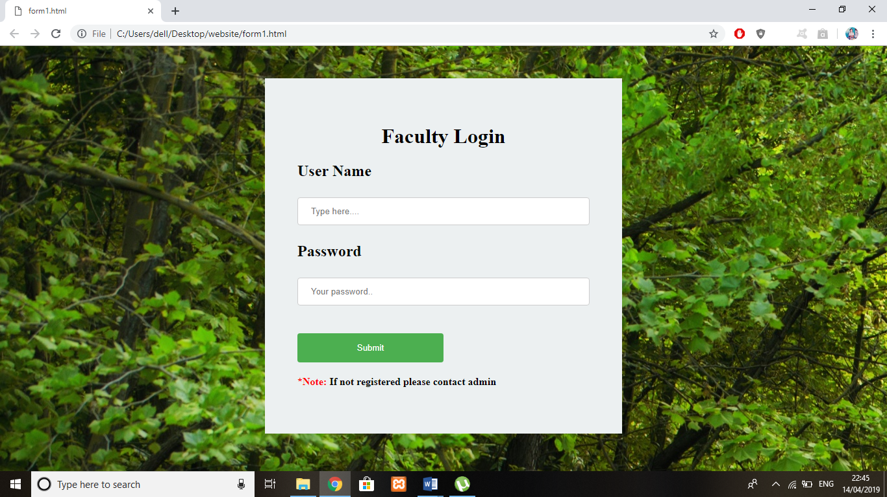

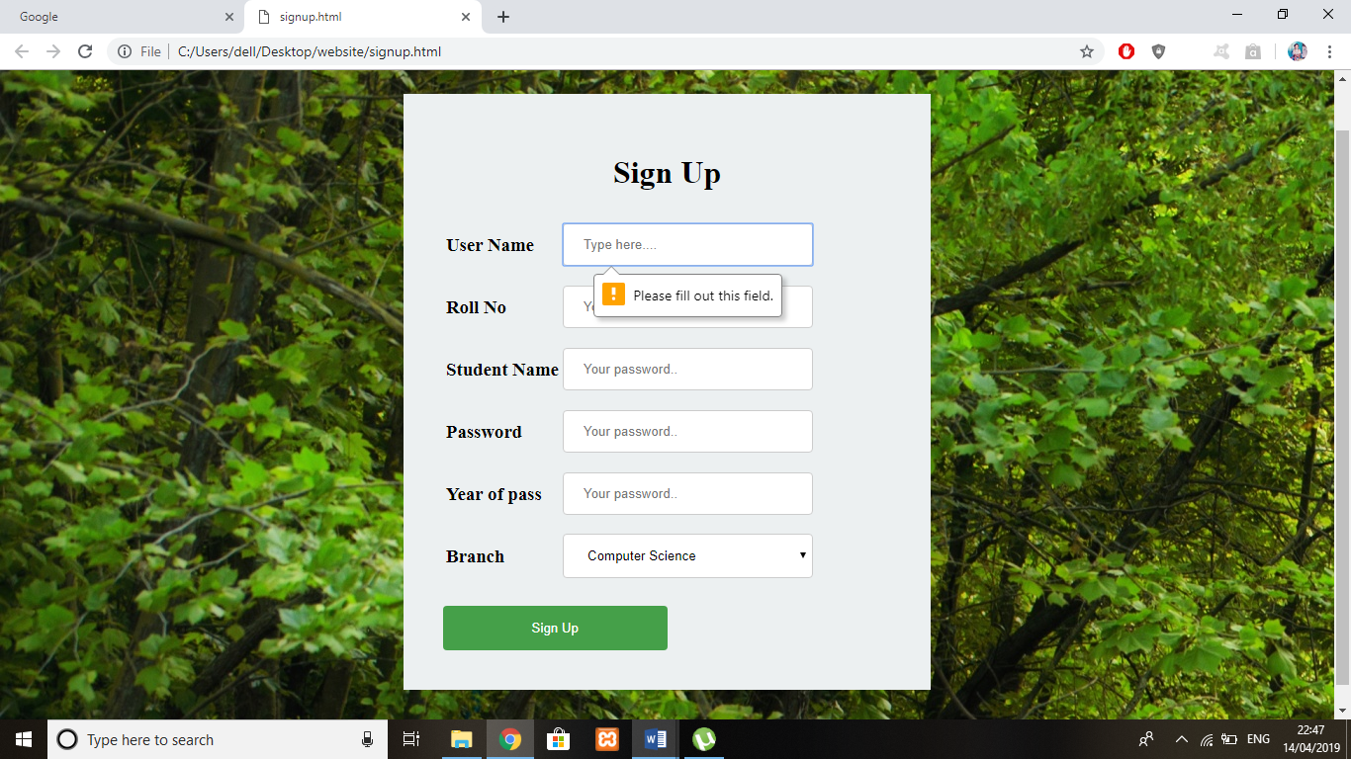

**CHAPTER 6 PROJECT RESULT**

**Input/ Output Design:**

1.home page

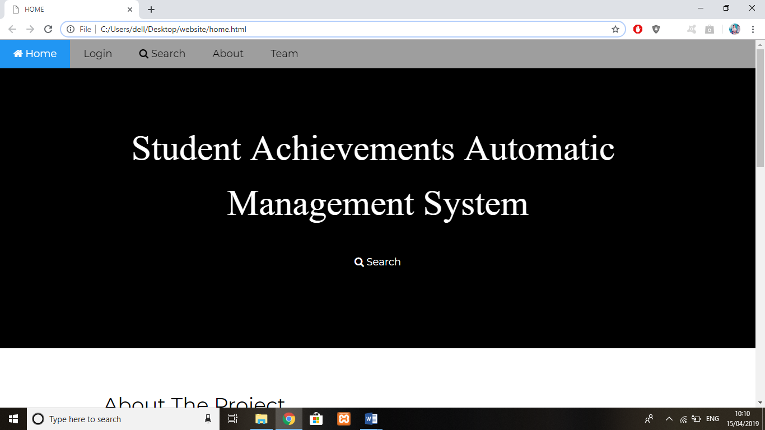

2.Login page

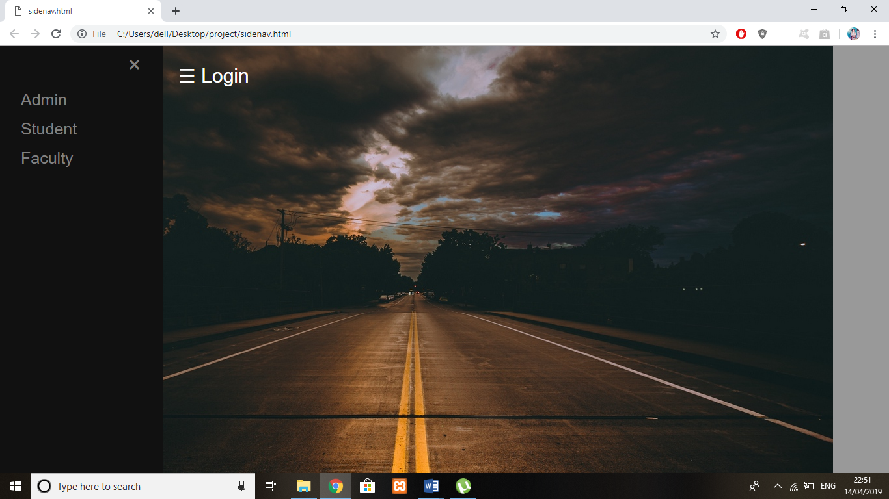

3.Faculty page

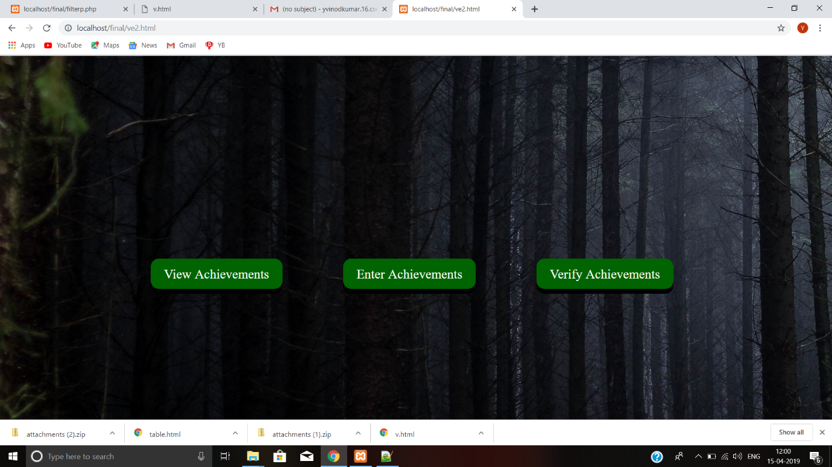

4. Search page

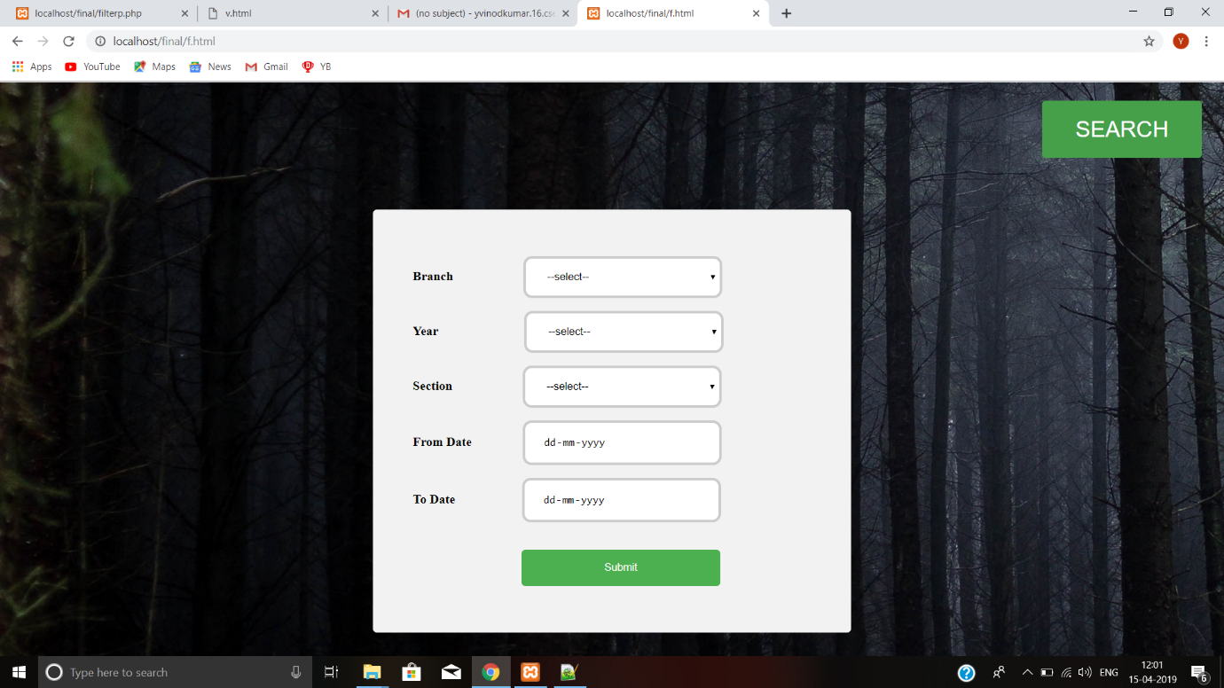

5.Search page by rollno

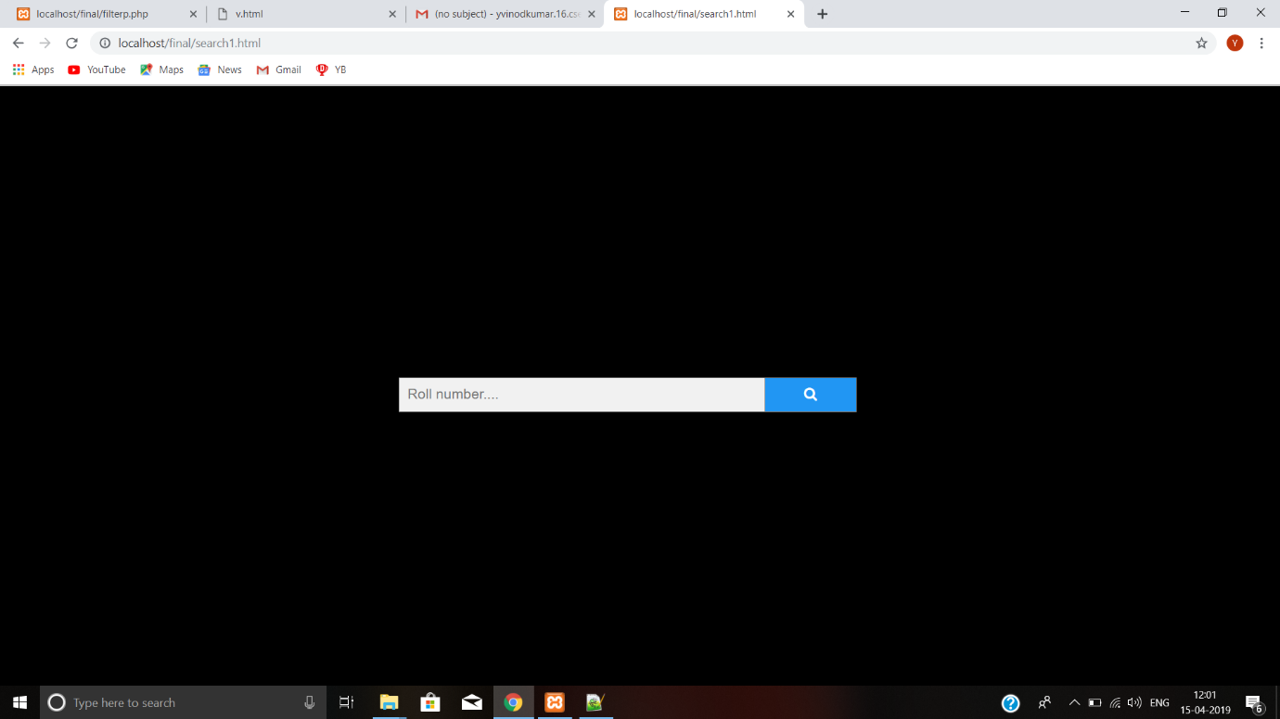

6.Student achievement entry form

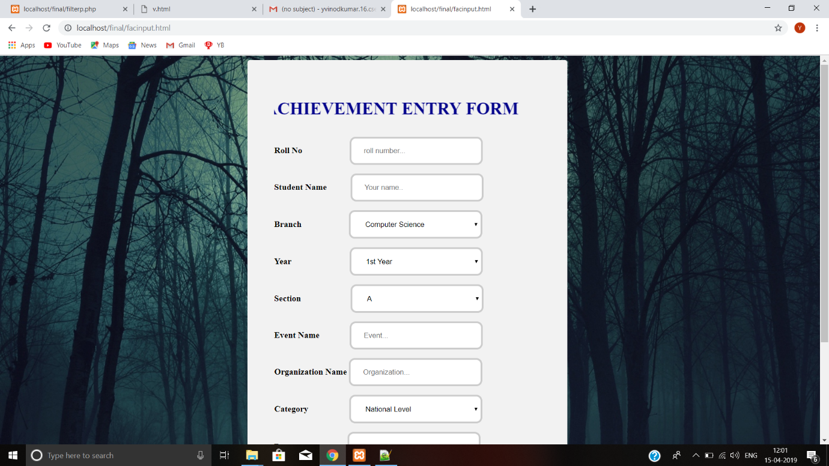

7. Faculty verifiction form

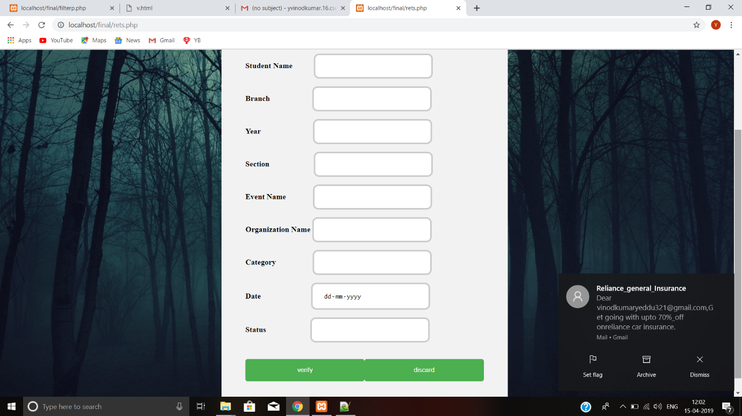

8.Student page

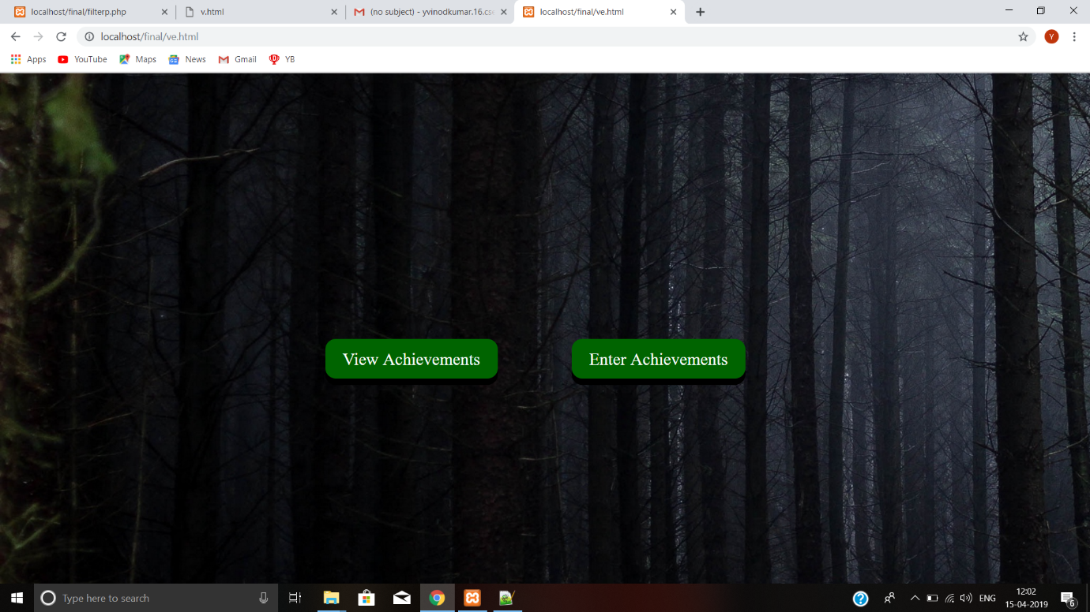

9.Output of search page

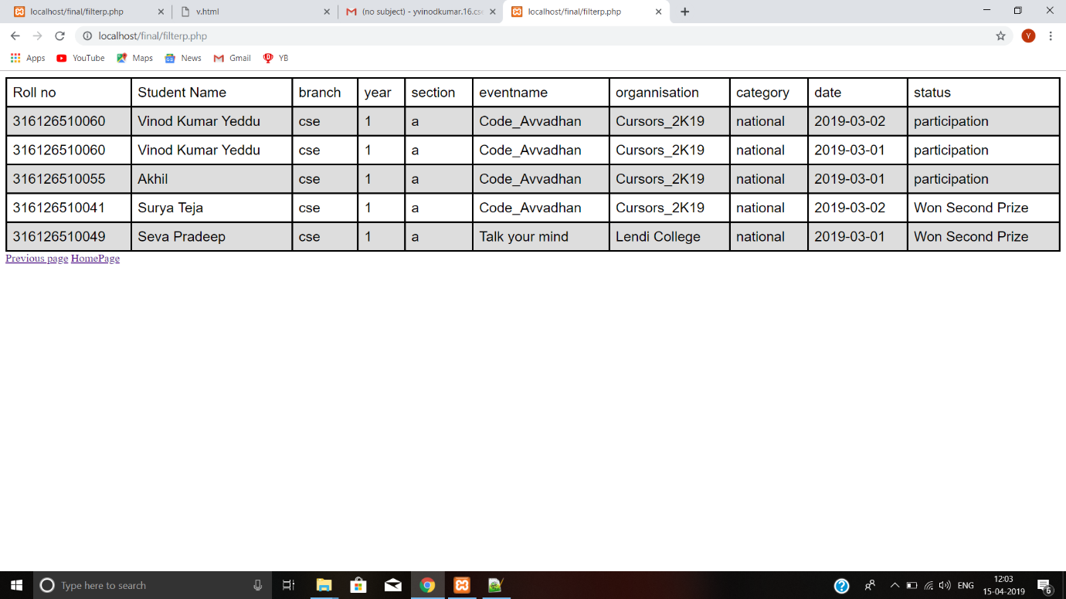

Chapter7 **CONCLUSIONS AND FUTURE EXTENSIONS**

Our project presented an online platform for a college to store and maintain and able to search details of students achievements easily and fastly and to maintain a large number of records.

**Future Enhancement:**

This project can further be developed by implementing an option including filters and more n.o of categories,where we can get a good and appropriate result for the search request by the user.

Also we can increase different users and we can also include achievements of the faculty of the college

Improving the search results based on various inputs from the user .

# **8.REFERENCES**

## Referred Websites:

https://[www.w3schools.com/](http://www.w3schools.com/)

https://[www.w3schools.com/php/](http://www.w3schools.com/php/)

https://[www.w3schools.com/php/php_form_validation.asp](http://www.w3schools.com/php/php_form_validation.asp)

**9.Uploading Project onto Git Hub**

